SQL Queries Questions:

Find duplicate row in sql

WITH CTE_Duplicates AS (
SELECT
*,
ROW_NUMBER() OVER(PARTITION BY column1, column2 ORDER BY some_id_column) as rn
FROM your_table_name
)
SELECT *
FROM CTE_Duplicates
WHERE rn > 1;

SELECT column1, column2, COUNT(*)
FROM your_table_name
GROUP BY column1, column2
HAVING COUNT(*) > 1;

To find the second highest salary in SQL, you can use different approaches depending on your database system. Here are three common methods:

1. Using a Subquery
SELECT MAX(salary) AS second_highest_salary
FROM Employee
WHERE salary < (SELECT MAX(salary) FROM Employee);
- This query finds the maximum salary that is less than the highest salary.

2. Using LIMIT or OFFSET (MySQL)
SELECT DISTINCT salary
FROM Employee
ORDER BY salary DESC
LIMIT 1 OFFSET 1;
- This query orders salaries in descending order, skips the highest salary (OFFSET 1), and retrieves the second highest.

3. Using a Common Table Expression (CTE) and ROW_NUMBER()
WITH RankedSalaries AS (
SELECT salary, ROW_NUMBER() OVER (ORDER BY salary DESC) AS rank
FROM Employee
)
SELECT salary AS second_highest_salary
FROM RankedSalaries
WHERE rank = 2;
- This query assigns a rank to each salary and retrieves the one ranked second.

If there is no second highest salary (e.g., all employees have the same salary), these queries will return NULL or no result, depending on the database system.

How to secure your Database:
Network Security
- 1. Isolate the Database Server:
Run the database on a separate server from the public-facing web and application servers to create a direct attack path.
- 2. Use Firewalls:
Implement firewalls to restrict network traffic, allowing only necessary ports and protocols to reach the database server.
- 3. Avoid Default Ports:
Do not use default network ports for your database, as attackers often scan for these common ports.
- 4. Restrict Access:
Limit network access to the database server and use private networks and VPNs where possible.

Access and Authentication
1. Implement Strong Authentication:
Use strong, complex passwords and enable multi-factor authentication (MFA) for all database accounts.
2. Enforce Least Privilege:
Grant users and applications only the minimum necessary permissions to perform their tasks.
3.Secure Credentials:
Store database credentials securely, separate from application code or configuration files.

To return data from a stored procedure using an output parameter, the following steps are involved:
CREATE PROCEDURE GetEmployeeInfo
@EmployeeID INT,
@EmployeeName NVARCHAR(100) OUTPUT,
@EmployeePosition NVARCHAR(50) OUTPUT
AS
BEGIN
SELECT
@EmployeeName = EmployeeName,
@EmployeePosition = EmployeePosition
FROM Employees
WHERE EmployeeID = @EmployeeID;
END;

Executing SP:
DECLARE @Name NVARCHAR(100);
DECLARE @Position NVARCHAR(50);
EXEC GetEmployeeInfo
@EmployeeID = 123,
@EmployeeName = @Name OUTPUT,
@EmployeePosition = @Position OUTPUT;
SELECT @Name AS 'Employee Name', @Position AS 'Employee Position

Write sql query to alter table

Example (SQL Server):
ALTER TABLE Employees
ADD Email VARCHAR(255)

Example (MySQL/PostgreSQL):
ALTER TABLE Products
MODIFY COLUMN Price DECIMAL(10, 2) NOT NULL;
Example (SQL Server):
ALTER TABLE Products
ALTER COLUMN Price DECIMAL(10, 2) NOT NULL;

Disadvantages of Indexing:
While database indexing significantly improves read performance, it introduces several disadvantages:
- Increased Storage Space:
Indexes require additional disk space to store the index structure alongside the actual data. This can become substantial for large tables and numerous indexes.
- Slower Write Operations:
Any operation that modifies data (INSERT, UPDATE, DELETE) also necessitates updating the corresponding indexes. This overhead slows down write operations, as the database must maintain data consistency across both the table and its indexes.
- Increased Complexity in Database Management:
Managing and optimizing indexes adds complexity to database administration. Choosing the right indexes, monitoring their performance, and performing maintenance tasks like rebuilding or reorganizing fragmented indexes require expertise and effort.
- Potential for Index Fragmentation:
Frequent data modifications can lead to index fragmentation, where the physical storage of the index becomes scattered. This can degrade query performance over time, necessitating regular maintenance.
- Impact on Backup and Recovery:
The presence of indexes can increase the time required for backup and recovery operations, as the index structures must also be backed up and restored along with the table data.
- Overhead for Query Optimizer:
While indexes generally help the query optimizer, an excessive number of indexes can sometimes complicate its job, leading to less optimal query plans in certain scenarios.
- Resource Contention:
In high-concurrency environments, indexes can introduce additional contention for resources like locks and latches, potentially impacting overall system performance.

What is Deadlock in SQL and how it is resolved?
Deadlocks occur when two processes want to access resources that are mutually being locked by each other.
Preventing Deadlocks:
- Access resources in the same order:
Ensure all transactions access shared resources (tables, rows) in a consistent, predefined order. This prevents circular dependencies.
- Keep transactions short and efficient:
Minimize the duration of transactions and the number of locks held. Shorter transactions reduce the window of opportunity for deadlocks.
- Use appropriate isolation levels:
Understand the impact of different transaction isolation levels on locking behavior and choose the most suitable one for your application, balancing concurrency and data consistency.
- Optimize queries and use proper indexing:
Efficient queries reduce the time locks are held. Good indexing can allow the database to locate data more quickly, reducing the need for extensive locking.
- Minimize the scope of locks:
Where possible, use row-level locks instead of page or table locks to reduce contention.
- Implement retry logic in applications:
If a transaction is chosen as a deadlock victim, the application should be designed to catch the deadlock error and retry the transaction.
- Consider using Row-Versioning Isolation Levels (e.g., Read Committed Snapshot Isolation - RCSI):
These can reduce the need for shared locks during read operations, thus lowering the chances of deadlocks involving readers and writers.
- Monitor and analyze deadlocks:
Use database tools and logs to identify frequent deadlock patterns and the resources involved, allowing for targeted optimization.

What Are Isolation Levels in SQL Server?
Isolation levels in SQL Server determine how one transaction is isolated from others in a multi-user environment. In simpler terms, they control how and when the effects of one transaction become visible to others.
The primary goal is to maintain data integrity and avoid problems such as:
- Dirty reads: Reading uncommitted data
- Non-repeatable reads: Data changes between reads
- Phantom reads: New records appear between queries

Why Do We Need Isolation Levels?
Proper isolation levels help you:
- Ensure data consistency and transactional integrity
- Avoid data anomalies (dirty reads, lost updates, etc.)
- Control lock durations to balance performance vs. consistency
- Fine-tune concurrency control based on business requirements
Best practice in 2025: Use appropriate isolation levels depending on your workload (OLTP vs. OLAP) to reduce deadlocks and improve query performance.

Real-Time Examples of SQL Server Isolation Levels

a. READ COMMITTED (Default)
Behavior: Reads only committed data. Waits if a row is locked by another transaction.

b. READ UNCOMMITTED
Behavior: Reads uncommitted (dirty) data. No locks, no wait time.

c. REPEATABLE READ
Behavior: Prevents changes to rows read by a transaction. No new updates or deletes allowed.

d. SERIALIZABLE
Behavior: Strongest isolation. Prevents phantom reads using range locks.

MongoDB excels at inserting or updating a large number of records. MSSQL is faster when selecting a large number of records.
While SQL is valued for ensuring data validity, NoSQL is good when it's more important that the availability of big data is fast.

Difference between SQL and Mongo DB
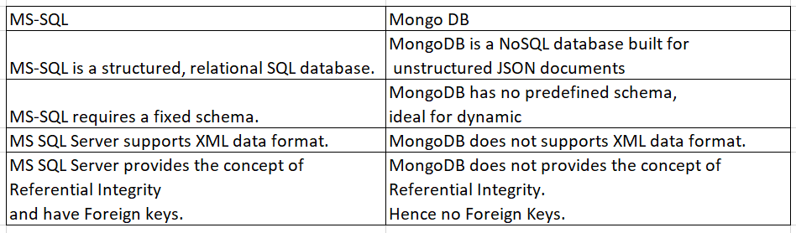

SQL Deadlock:
Preventing deadlocks using code primarily involves two strategies: writing Transact-SQL (T-SQL) with a consistent access pattern and using application-side retry logic to automatically restart a transaction that the database has chosen as a deadlock victim.
T-SQL Code for Prevention
You can minimize deadlocks by ensuring a consistent order of operations and, in some cases, setting deadlock priority within your SQL code itself.
- Consistent Object Access Order: Always access tables (and rows within them) in the same logical order across all your transactions.
sql
-- Session 1
BEGIN TRANSACTION;
UPDATE TableA SET Value = 1 WHERE Id = 1;
-- Other operations...
UPDATE TableB SET Value = 1 WHERE Id = 1;
COMMIT TRANSACTION;

-- Session 2 must follow the same order to prevent deadlocks:
BEGIN TRANSACTION;
UPDATE TableA SET Value = 2 WHERE Id = 1;
-- Other operations...
UPDATE TableB SET Value = 2 WHERE Id = 1;
COMMIT TRANSACTION;
Use code with caution.
- Setting Deadlock Priority: You can influence which transaction becomes the victim in a deadlock scenario. The one with the lowest priority will be terminated. The default is NORMAL (0).
sql
-- Set the current connection's transaction priority to Low
SET DEADLOCK_PRIORITY LOW;
BEGIN TRANSACTION;
-- Your transaction logic here
COMMIT TRANSACTION;
Use code with caution.
- T-SQL Retry Logic: You can embed simple retry logic directly into stored procedures using TRY...CATCH and a WHILE loop.
sql
DECLARE @MaxRetries INT = 3;
DECLARE @TryCount INT = 0;

WHILE (@TryCount < @MaxRetries)
BEGIN
SET @TryCount = @TryCount + 1;

BEGIN TRY
-- Start your transaction
BEGIN TRANSACTION;

-- Your UPDATE, INSERT, DELETE statements here
-- Example:
UPDATE Products SET Quantity = Quantity - 1 WHERE ProductId = 1;

COMMIT TRANSACTION;
-- If we reach here, the transaction succeeded, exit the loop
SET @TryCount = @MaxRetries;
END TRY
BEGIN CATCH
IF (ERROR_NUMBER() = 1205) -- 1205 is the SQL Server deadlock error code
BEGIN
ROLLBACK TRANSACTION; -- Rollback the current attempt
-- Optional: Add a small WAITFOR DELAY here to avoid immediate re-deadlock
WAITFOR DELAY '00:00:00.100';
IF (@TryCount >= @MaxRetries)
BEGIN
THROW; -- Rethrow the error if all retries are exhausted
END
-- Otherwise, the loop continues for the next attempt
END
ELSE
BEGIN
-- Handle other errors or rethrow
ROLLBACK TRANSACTION;
THROW;
END
END CATCH
END
Use code with caution.

Application-Level Retry Logic (C# Example)
Implementing retry logic in your application code is generally a more robust approach, as it moves the retry mechanism away from the database server's resources and provides a better user experience.
Here is a C# example using Microsoft.Data.SqlClient that catches the specific deadlock error code (1205) and retries the operation with a short delay.
csharp
using System;
using System.Data.SqlClient;
using System.Threading;

public void ExecuteWithDeadlockRetry(Action transactionAction, int maxRetries = 3)
{
int attempts = 0;
while (attempts < maxRetries)
{
try
{
// The database operation is performed here, often within a 'using (SqlConnection conn = ...)' block
transactionAction.Invoke();
return; // Success, exit the method
}
catch (SqlException ex)
{
if (ex.Number == 1205) // Error 1205 is SQL Server deadlock victim
{
attempts++;
if (attempts >= maxRetries)
{
// Log the final failure
Console.WriteLine($"Deadlock occurred, max retries ({maxRetries}) exceeded. Throwing exception.");
throw;
}
else
{
// Log retry attempt and wait briefly (e.g., exponential backoff)
Console.WriteLine($"Deadlock occurred. Retrying attempt {attempts}/{maxRetries} after a delay.");
// Use a short, randomized delay to prevent immediate re-deadlocking
Thread.Sleep(100 * attempts);
}
}
else
{
// Not a deadlock, throw the exception as normal
throw;
}
}
}
}

// Example usage in your application code:
// ExecuteWithDeadlockRetry(() => {
// // Your ADO.NET or ORM code that runs within a transaction goes here
// // e.g., command.ExecuteNonQuery();
// });
Use code with caution.

SQL Query:
To find customers with only a single order using ROW_NUMBER(), you can utilize a Common Table Expression (CTE) to assign a row number to each order partitioned by customer, and then filter for customers where the maximum row number assigned is 1.
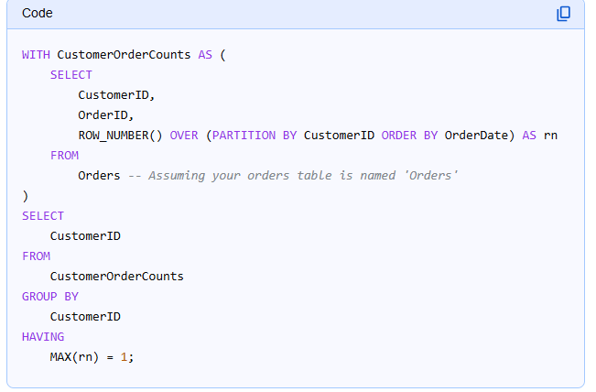

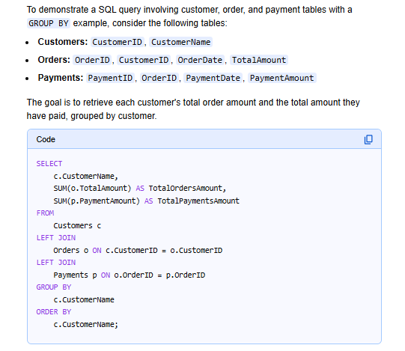

Here is a basic example of a stored procedure for paging:
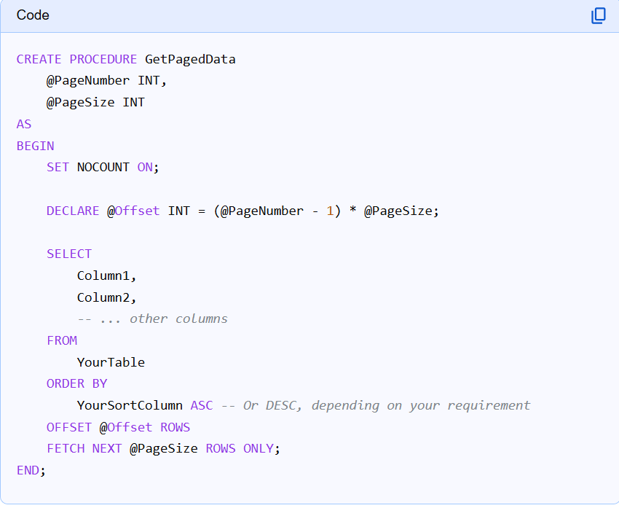

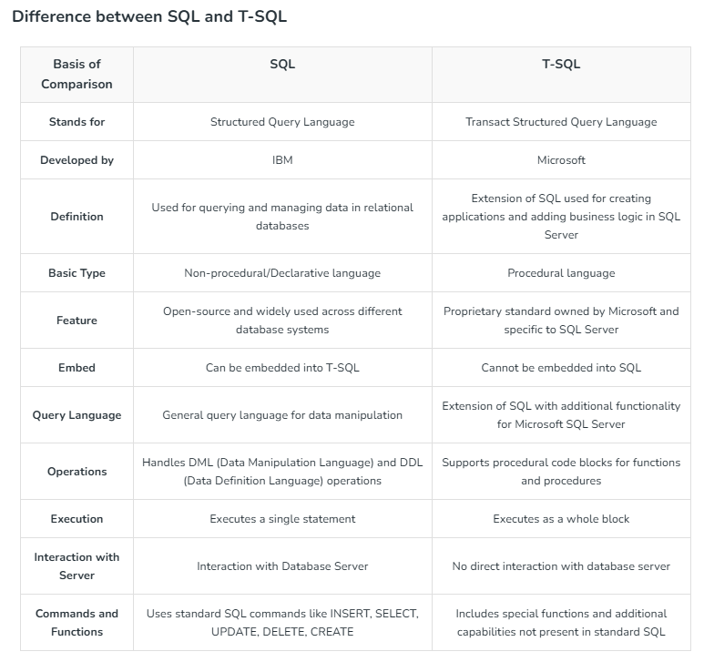

Key Differences Summarized:
- Matching Behavior:
CROSS APPLY requires a match from the right-side expression, similar to INNER JOIN. OUTER APPLY includes all rows from the left side, filling NULL for non-matches from the right, similar to LEFT OUTER JOIN.
- Result Set:
CROSS APPLY filters out left-side rows without a match. OUTER APPLY preserves all left-side rows.
- Usage:
They are primarily used when the right-side expression is a table-valued function or a derived table that needs to reference columns from the left-side table on a row-by-row basis.

No Lock:
In SQL Server, NOLOCK is a table hint that allows reading data without placing shared locks on the table. It's often used in SELECT statements to improve query performance and reduce blocking, but it comes with certain trade-offs. This hint is sometimes referred to as a "dirty read" because the data being read may not be fully committed.

Cross Join
The CROSS JOIN in SQL creates a Cartesian product of two tables. This means that every row from the first table is combined with every row from the second table, resulting in all possible combinations. Unlike other join types, a CROSS JOIN does not require a join condition (like an ON clause).

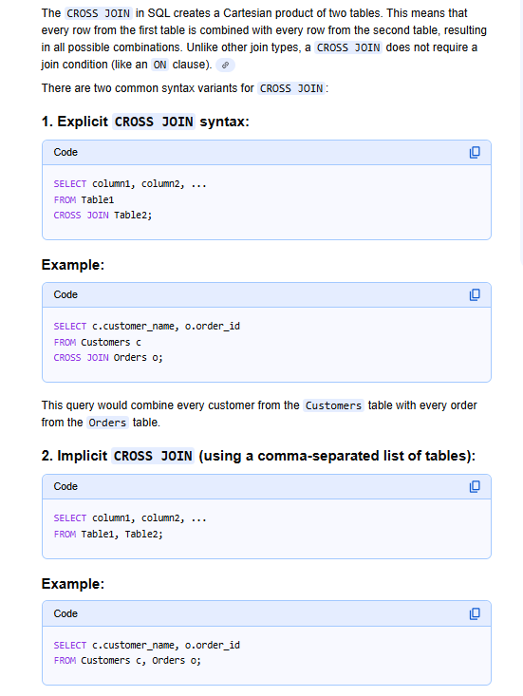

User-defined functions (UDFs):
User-defined functions (UDFs) in SQL are custom functions created by users to encapsulate specific logic or calculations. They allow for modular programming, reusability of code, and can enhance the flexibility and efficiency of SQL queries.
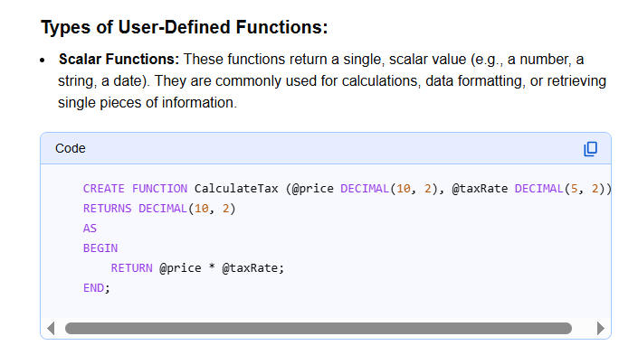

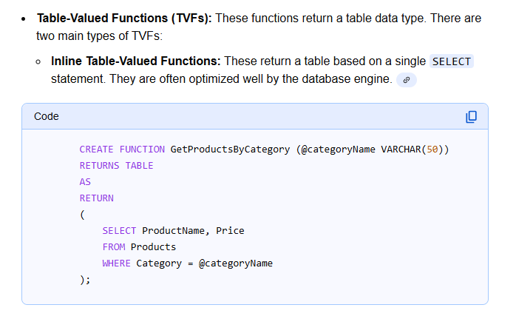

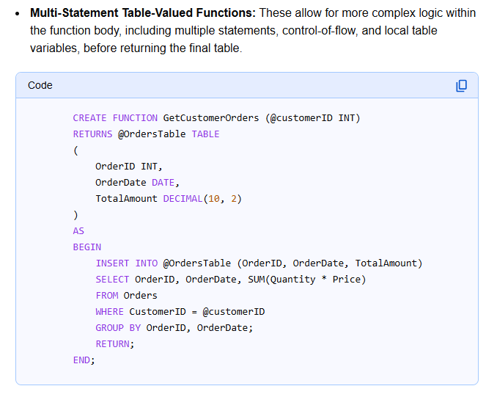

SubQuery Type:
https://www.geeksforgeeks.org/sql-server/sql-server-subquery/

Primary Key:
A table can have only one primary key. This is a fundamental principle of relational database management systems (RDBMS) [1, 2, 3, 4].
The reasons why a table is limited to a single primary key are directly related to the key's definition and purpose:
- Unique Identification: The core function of a primary key is to uniquely identify each row (or record) in the table [1, 2, 4]. If multiple primary keys were allowed, it would create ambiguity in how a single row is definitively identified across the database [3].
- Data Integrity and Non-Nullability: A primary key enforces two crucial data integrity constraints: the entity integrity constraint and the non-null constraint [1, 4].
  - It guarantees that no two rows are identical based on the key's value(s).
  - It ensures that the column(s) comprising the primary key cannot contain NULL values, ensuring every record always has an identifier [1, 2].
- Relationship Building (Foreign Keys): Primary keys are the target for foreign keys in other related tables, establishing relationships between data [1, 3, 4]. If there were multiple potential "primary" identifiers, linking tables would become confusing and inconsistent.

